Solex

Robocrop
Precision guidance system

Users Guide
Version 2.8
Contents

1. Preface.......................................................................................... 3
2. Safety............................................................................................ 4
3. Assembly....................................................................................... 5
Step 1 – Mounting the console........................................................... 5
Step 2 – Connecting the power supply.................................................. 5
Step 3 – Setting up the linkage arms.................................................... 5
Step 4 – Reducing lateral movement.................................................... 5
Step 5 – Levelling the implement........................................................ 5
Step 6 – Connecting the hydraulic hoses.............................................. 5
Step 7 – Connecting implement loom to the console................................ 5
Step 8 – Starting the tractor and console.............................................. 6
Step 9 – Checking hydraulic operation................................................. 6
4. Working screen – the basics......................................................... 7
5. Getting to work in the field............................................................ 8
Step 1 – Selecting configuration file and crop size..…………………….... 8
Step 2 – Stationary alignment to crop rows........................................... 8
Step 3 – Adjusting camera height and inclination.................................... 9
Step 4 – Adjusting camera lateral position............................................. 10
6. Notes on operation with a correctly set up machine…………….. 11
7. Information screens and menus….………………………………… 12
Working screen functions.………………………………………. 12
Setup menu…………………….………………………………… 13
Advanced diagnostics menu….………………………………... 14
Configuration file editor…….…………………………………… 16
8. Maintenance and storage............................................................. 20
9. Troubleshooting............................................................................ 21
10. Service ……............................................................................... 23
1. Preface
Congratulations on purchasing a Robocrop precision guided hitch.
The Robocrop precision guided hitch is guided by a computer controlled steering system.
There are 3 main components to the system.
- A video camera mounted on moving part of the hitch looking ahead at a wide area of crop normally taking in several rows.
- A cab mounted console containing a computer to analyses camera images and find exact row centres.
- A hydraulic side shift controlled by the console keep the camera centrally over the crop rows and the implement precisely on track.
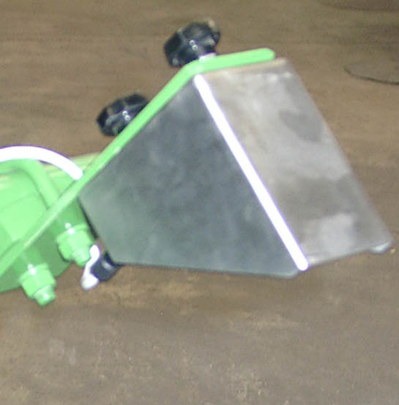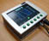
Camera
Console
Micro controller and valves for hydraulic side shift
Schematic of Robocrop on a rear mounted inter-row cultivator with side shift
Robocrop uses a colour camera to pick out green crop and weed from backgrounds containing soil, stones and trash. (Consult your Solex dealer for systems to work in red crops.) Robocrop locates crop rows within a scene by matching a template corresponding to the known planting pattern with crop rows as they appear in the camera image. That image is displayed live on the console with the template overlaid as green lines.
Matching a template to a broad area of crop rather than locating individual rows improves reliability especially when parts of those rows are not present or obscured by weeds. Template shape is determined by a configuration file pre-programmed to suit a particular crop planting geometry and implement configuration. Different configuration files are available for different crops and implements.
An accurate match between the template and crop rows is important for accurate row following.
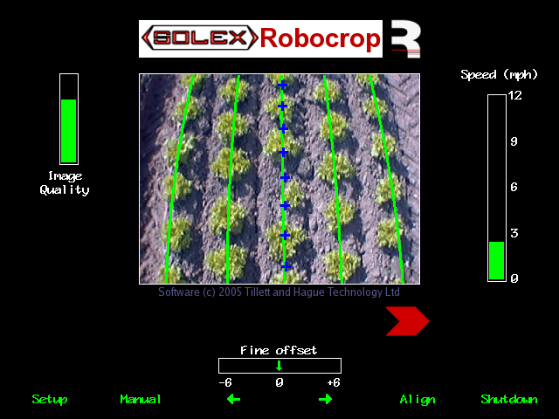
Console working screen showing a typical live video image with the template superimposed as green lines over crop rows.
2. Safety

- When carrying out repairs or adjustments to a side shifting hitch or implement, ensure that the Robocrop system is switched off and also that the hydraulic supply is off.

- Never conduct maintenance work on the side shift mechanism while it is supporting the implement.

- The side shift mechanisms forms pinch, trap and shear points. Be aware of these when carrying out maintenance.

- Regularly check the condition of hydraulic hoses and fittings on the side shift mechanism.

- Do not allow other persons to ride on or work near the hitch or implement when it is in operation.

- The power supply cable has a 20Amp fuse fitted near to the battery terminals. This is for short circuit protection and must not be omitted.

- When routing the loom and power supply cables ensure that they do not cause a restriction or trip point in the cab.
3. Assembly
The following steps outline how the Robocrop precision guided hitch should be set up.

Step 1 - Mounting the console
Mount the console in the tractor cab in a position where it can be clearly seen but does not obscure operator's visibility. Four screws (M6 x 12) and tapped holes in the rear of the console facilitate mounting to a bracket. Use of a suction bracket for mounting on the tractor wind screen is recommended as it provides good vibration isolation.
Caution
- The console should be protected from severe vibration.
- Do not use longer screws than those supplied otherwise damage to the console may result!
Step 2 – Connecting the power supply
The power supply cable should be connected directly to the tractor battery.
Caution
- Route the cable carefully ensuring that it cannot become trapped or chaffed.
- The 20amp fuse at the battery terminal end of the cable is for short circuit protection and must not be removed.
- The polarity is denoted by + and – marker rings on the cables. The fuse is on the + cable.
Step 3 – Connecting to the tractor
Position the tractor on a level surface. Check that the tractor’s lower link arms are evenly adjusted and hitch the tractor to the 3 point linkage points on the side shift frame.
Caution
- The side shift 3 point linkage points are designed to accommodate standard category 2 and 3 dimensions and so must be attached to an appropriate tractor linkage.
- Once the 3 point linkage is correctly fitted stop the tractor and apply the handbrake.
Step 4 – Reducing lateral movement
Adjust the stabiliser links or use packing to prevent lateral movement of the lower link arms.
Caution
- It is very important that there is no lateral movement in the linkage.
Step 5 – Levelling the hitch
With the hitch at the normal operating height, adjust the top link so that the hitch is vertical.
The control system loom and hydraulic hoses can now be routed from the hitch to the tractor.
Caution
- Clipping the loom and hoses to the top link should keep them clear of catch points.
- Make sure that the linkage can be operated over its full range without stretching or chaffing the loom conduit or hoses.
Step 6 – Connecting the hydraulic hoses
Plug the hoses into a suitable double acting valve connection on the tractor. Markers on the hoses indicate the following:
Supply – RED Return - BLUE.
Step 7 – Connecting the implement loom to the console
The loom from the implement should be routed into the tractor cab and through to the console.
Caution
- Take care not to allow the loom to restrict access to or exit from the cab or act as a trip point.
Plug the large multi pin plug into the socket in the bottom of the console.
Caution
- Note the correct alignment of the tabs in the plug and socket.

Wide alignment tab Wide alignment slot
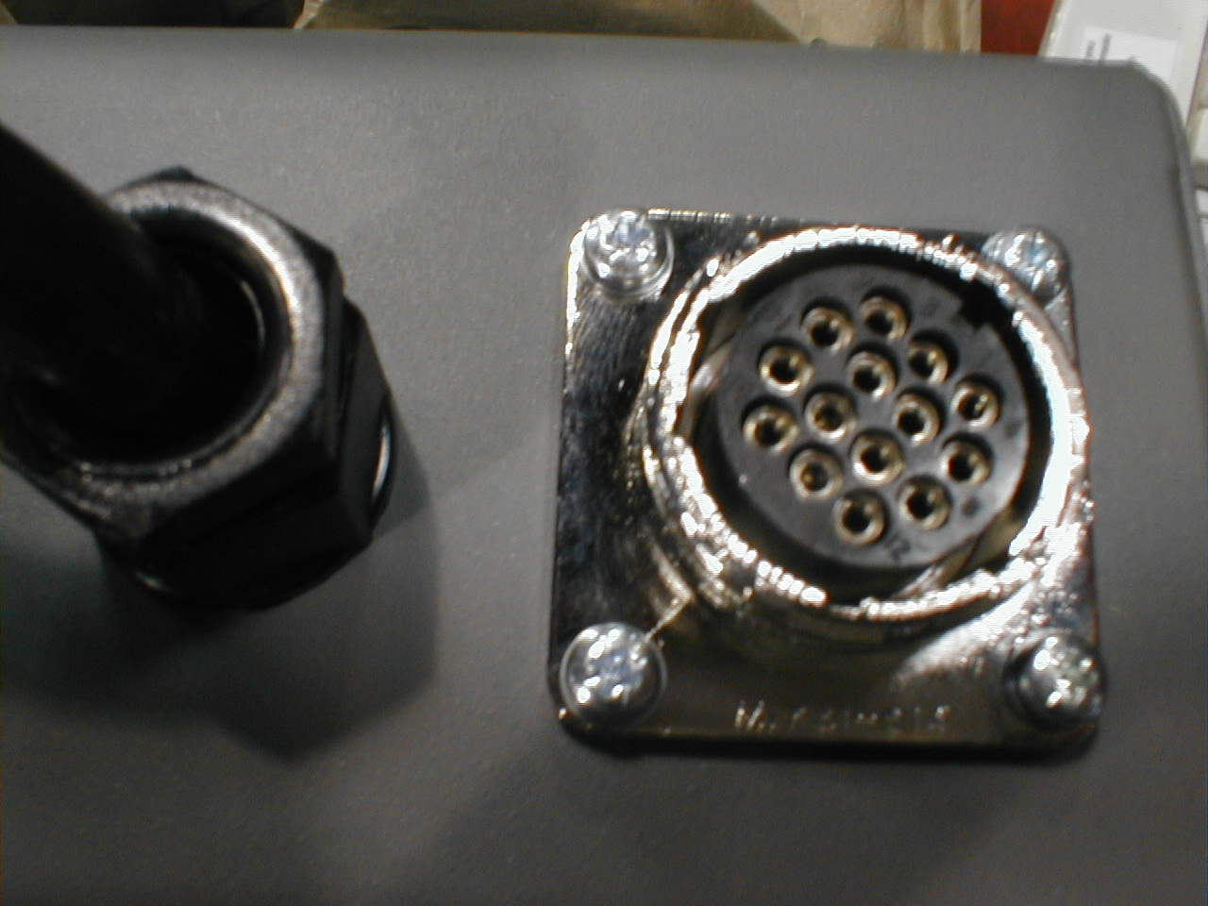
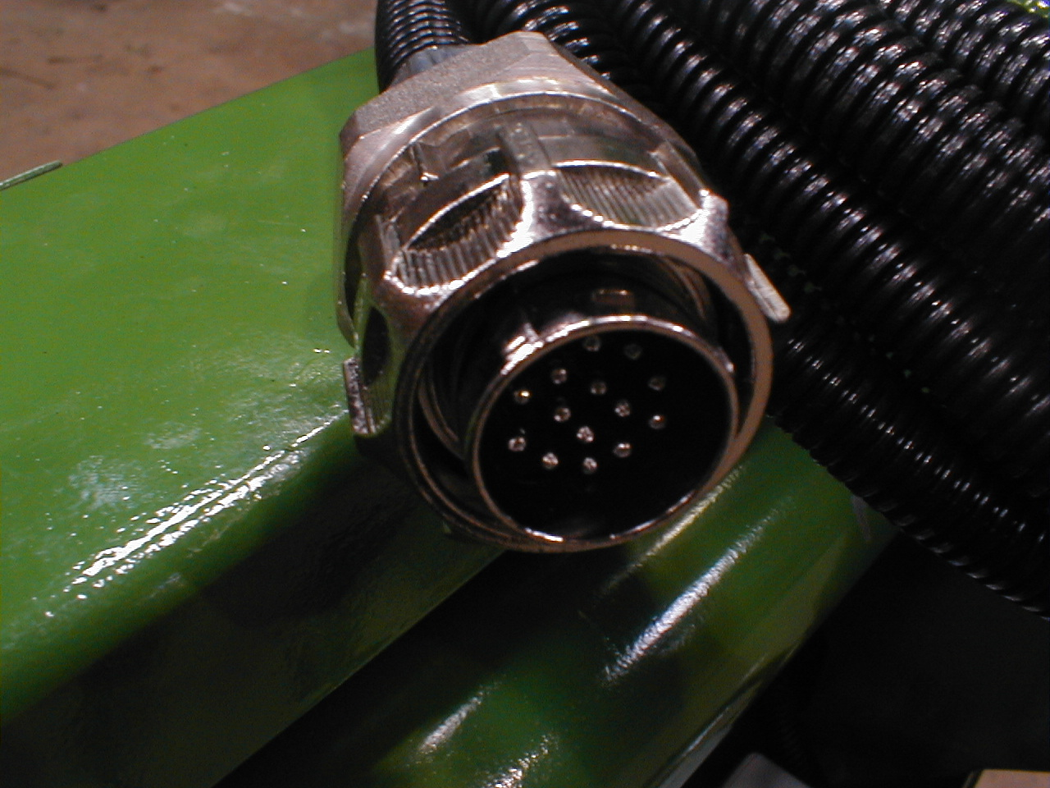

Step 8 – Start the tractor and console
With the hitch in the lowered position check that the spool valve is in neutral and all persons are well clear. Start the tractor then switch on the console. Wait for the system to "boot up". After a few screens of familiar PC boot up text the graphics and live camera picture should appear, this is referred to as the working screen, as shown described in section 4.
Step 9 – Checking hydraulic operation
Set the tractors hydraulic control to provide a constant flow to the implement with the facility to disengage the supply immediately should a fault occur.
Once the system has booted up and the working screen is displayed, lift the hitch clear of the ground and engage the hydraulic supply. The side shift should centralise.
If the side shift was already central and you wish to test it press the second button from the left on the bottom of the console (labelled “manual” on the working screen). The hydraulic side shift is now in manual mode and can be operated via the third and fourth buttons (labelled with left and right arrows on the working screen). Each press of a button steps the side shift by 7% of its stroke. Repeated pressing (but not holding the key down) will result in continuous travel up to the end of the stroke. This procedure can be used to check that hydraulic flow is in the correct direction and that the side shift rate is correct. A normal side shift rate would be 4”/s (e.g. 3s to travel a I ft stroke). To return to normal automatic mode press the same button (now with “manual” highlighted) again. The side shift will stay in the position it was placed under manual control until the hitch is lowered and raised again, or the machine starts to travel forward.

Caution
- Side shift travel all the way to one side on lifting the implement may indicate that the hydraulic supply is connected the wrong way.
- Rapid side shift/disc oscillations back and forth about the central position indicate that the hydraulic flow rate is too high. The tractor flow control should be turned down. Alternatively the hydraulic flow control valve may be adjusted, see picture.
- Only adjust the flow control valve with the tractor engine switched off.
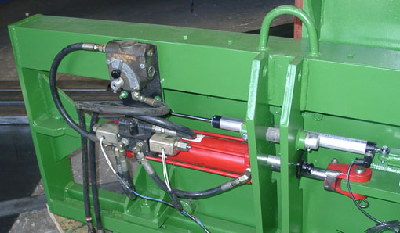

The hitch is now ready for work and be connected to the implement.
Before proceeding to the operational phase it is worth familiarising yourself with the working screen.
4. Working screen – the basics
On start up the console displays the working screen as illustrated below. It has the following features:
- A live camera video image in the centre of the screen. Superimposed over the live video image are two sets of markings. The first are green lines representing the template to which crop rows are matched. The second are a series of eight crosses arranged from the top to the bottom of the image. These represent how well the template lines up at different levels up the image. Blue crosses indicate a good match. Yellow and red crosses indicate a poor match.
- An image quality gauge to the left of the screen giving a reading of likely tracking performance. The higher the green bar the better. A low bar indicates either a poor template match or poorly defined crop rows. Robocrop will under most circumstances operate down to an indication of approximately 25% albeit at reduced accuracy.
- A warning triangle (not shown in the illustration below) indicating poor tracking is displayed if Robocrop estimates that the error in lateral implement position exceeds 25mm. On seeing this warning the user should check performance on the ground.
- A speed gauge on the right shows forward speed. This should match tractor speed.
- A green dot and red chevrons below the image indicate side shift position/disc angle. It is normal for side position to vary and be off centre. It is not normally necessary for the driver to steer to the chevrons. A red chevron with a vertical bar indicates the limit of travel has been reached. This should not occur for extended periods.
- The fine offset gauge shows the amount of left or right bias set by the user. This is used to compensate for minor lateral camera misalignment, but can also be useful on side slopes.
Operator controls are via 6 buttons located along the base of the display screen. These are known as soft keys because their function changes depending on the screen being viewed. Soft key 1 (Sk1) is on the left and soft key 6 (Sk6) is on the right. Current soft key function is indicated immediately above the button on the display screen. A full description of these functions is given in section 7 page12.

Sk1 Sk2 Sk3 Sk4 Sk5 Sk6 Power

5. Getting to work in the field
The most important procedure to ensure good guidance is to match the template, as illustrated by the green lines, to the crop rows as they appear in the live video image. The following steps outline how to get the best match and hence good guidance.
Tip
For the first few hundred meters of running after commissioning, or after selecting a different configuration file, Robocrop learns (or re-learns) a term known as camera skew (see section 7.3) Camera skew compensates for minor errors in camera orientation in the horizontal plane. Wherever possible we recommend that set up runs (step 4) are conducted in crop showing the clearest rows available at the time so that camera skew is learned as quickly and accurately as possible. High visibility rows also help manual alignment checks (step 3). We also recommend that side slopes are avoided during initial running. Once set up is complete more challenging situations can be tackled.
Step 1 – Selecting configuration file and crop size
From the working screen press button Sk1 labelled setup. This switches the display to the setup screen.
The top line of this screen indicates crop size (height) settings under categories of small (< 2”) medium (2” - 6”) and large (> 6”). Ensure that the highlighted option corresponds to the crop being used for setup and initial running.
Check the detail at the bottom of the screen to ensure that the configuration file settings selected matches crop and camera geometry.
If either crop size or configuration settings are not correct refer to section 7 for instructions on making the necessary changes.
To return to the working screen press Sk5 labelled “OK”.

Step 2 – Stationary alignment to crop rows
Draw into the crop and set the cultivator down onto a typical section of crop row. The cultivator should be set onto the row as accurately, and as straight as possible with the camera at its normal operating height.
Press Sk5 labelled “Align”, The overlaid green lines representing the template should lock in the centre of the screen.
Tip
If crop rows are difficult to see in the live video image you can enhance them by placing high visibility objects such as a strip of wood exactly over the row centre line.
Caution
If the grid appears asymmetric the camera skew value may need resetting. Refer to the advanced diagnostics menu in section 7.3.
Step 3 – Adjusting the camera height and inclination angle
Camera height and vertical inclination angle should now be adjusted to get the best possible match between the green template lines overlaid on the screen and crop rows in the live video image.
Adjusting camera height

If the camera is too low then the template will appear narrower than the crop rows. In this case raise the camera.

If the camera is too high then the template will appear wider than the crop rows. In this case lower the camera.

Good tracking will only be achieved if the template lines are centred on all of the rows being tracked.

Adjusting camera inclination
If the template matches at the top of the screen but not at the bottom, or vice versa, then the camera inclination angle will need adjusting.

If the template lines appears narrower than the crop rows at the top of the image but wider at the bottom then the camera is inclined down too far. In this case rotate the camera up so it views further ahead.

If the template lines appears wider than the crop rows at the top of the image but narrower at the bottom then the camera is inclined up too far. In this case rotate the camera down so it views less far ahead.

Note Remember to tighten any bolts loosened in the process of adjustment.
Step 4 – Initial running and adjusting camera lateral position
When you are happy you have a good template match press the button labelled “Align” again to return to the normal working screen ready for tracking. You can be sure that the machine is ready for tracking if a line of crosses have appeared down the centre of the display.
Note
For initial set up runs almost all the crosses should be coloured blue and form a relatively straight vertical line. If this is not the case, or the image quality bar is below 50%, either the machine is not correctly set up, or the crop rows are not sufficiently well defined for initial running.
If tracking appears good set off slowly into the crop. The implement should quickly align with crop rows. It is likely that after a short distance it will have settled at a small lateral offset. Small offsets can be corrected using the fine offset facility available from the working screen. The buttons labelled with left and right arrows adjust the fine offset whose current position is displayed centrally below the live video image. Each press of an arrow key biases the side shift in steps by 3/8”. Continue down the field stopping occasionally to check lateral position. If the required fine offset exceeds the available number of steps the camera should be physically moved as described below and step 4 repeated.
It is the operator's responsibility to decide at which point the vision guidance system becomes 'lost'. If the system losses track of crop rows the operator should carefully guide the implement through to the next good reference.
Solex accept no responsibility for damage to or loss of crop whatsoever.
After approximately 500 yards of running Robocrop should have learnt camera alignment and lateral bias should therefore have stabilised. If the fine offset is set to greater than two steps we recommend physically moving the camera laterally by the equivalent distance and resetting the fine offset to zero.
Tip
If the fine offset is set to the left then the camera should be moved to the right as viewed from behind looking forward.
Once you are confident that Robocrop is tracking accurately and reliably forward speed can be increased. Working speeds up to 8 mph can be accommodated with Robocrop, however the mechanical effect of shares and shields on the soil and its effect upon plants will determine if this is achievable.
6. Notes on daily operation with a correctly set up machine
- Before operation check that electrical and hydraulic connections are secure and that there are no obstructions to side shift movement.
- On first setting the implement down in the field check that the green overlaid lines representing the template line up with crop rows and that overlaid blue crosses have appeared approximately central in the image.
- Proceed with caution for first few meters checking that Robocrop’s speed gauge matches the tractors and that implement alignment is good. If performance is satisfactory speed can be increased. Robocrop’s tracking should be satisfactory up to 8 mph, though soil movement considerations may dictate a lower operating speed.
- Robocrop remembers the fine offset settings from previous sessions and so there should not normally be any need to adjust this unless changes have been made to camera position.
- Operating on side slopes will result in some lateral error due to the tractor “crabbing” across the slope. Normally this is not significant, but in extreme cases it may be necessary to use the fine offset function to compensate. If operating in this way remember to reverse the bias when heading in the opposite direction and to return to a neutral setting when stopping work or moving to a flat area.
- Each time the implement is lifted at row ends it will centralise ready for the next run.
- At the end of the day shut down the system by pressing the button on the far right labelled 'Shutdown' and wait until the report 'system halted' is displayed, then switch off the power. If this procedure is not followed the latest settings such as fine offset will not be retained.

If in doubt about any machine settings or operating procedures please contact your Solex dealer.
7. Information screens and menus

Robocrop has a graphical working screen that conveys all the information necessary for normal operation. A description of this screen is given in section 4.
A series of six buttons along the bottom of the display allow the operator to access user controls such as fine offset and manual control of the side shift. The function of these buttons is described by labels on the video screen immediately above each button.
Set up procedures and more advanced information can be accessed via additional screens that can be navigated to via the working screen. The function of the six buttons below the display, known as soft keys, changes with each screen, but is always described by the label displayed above.

7.1 Working screen functions (see section 4 for an explanation of the graphics)
Sk1 Labelled “Setup” this button accesses the setup menu (section 7.2).
Sk2 Labelled “Manual” this button switches the system into manual mode. It disables the vision system and allows the user to move the side shift left or right manually in steps of 7% of stroke for each press of Sk3 or Sk4. To prevent mechanical damage this function only operates when the hitch is lifted or moving forward. To return to the vision guidance mode press the button again. The side shift remains in the position it was placed manually until forward movement under vision guidance is commenced, or an implement lift is detected. The later will centralise the side shift.
Sk3 Moves fine offset 3/8” to the left, or when in manual mode side shifts 7% of stroke to the left.
Sk4 Moves fine offset 3/8” to the right, or when in manual mode side shifts 7% of stroke to the right
Sk5 Labelled “Align” this button locks the green lines representing the template centrally in the picture whilst retaining a live video image. This is useful when making camera adjustments to match crop rows with the template. Pressing the button again resumes normal vision guidance. The align mode is exited automatically and normal vision guidance resumed if the hitch is raised or starts moving.
Sk6 Pressing this button labelled “Shutdown” enters a shut down screen from which you can elect to proceed with the shut down process by operating SK5, labelled “exit”. Wait until the script says ‘system halted’ then turn off the main power switch.

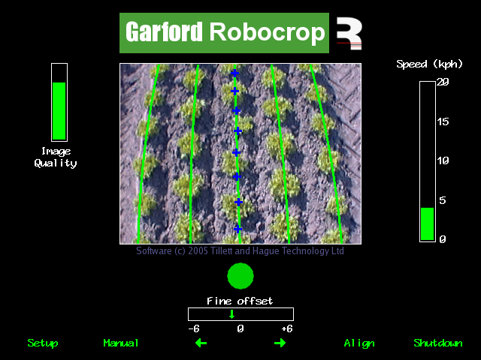

Sk1 Sk2 Sk3 Sk4 Sk5 Sk6 Power
7.2 The Setup Menu
The setup screen can be reached by pressing the appropriate button (Sk1) from the working screen. Two settings can be altered in the Setup menu.
Navigation within the set up screen is achieved by moving the cursor over options using buttons labelled with arrows (Sk2-Sk4). When the cursor is over an appropriate setting it can be selected by pressing the button labelled “OK” (Sk5)
“Crop size” increases template size to compensate for the crop canopy getting closer to the camera as it grows. This avoids physically adjusting camera height when moving between crops of different heights. Robocrop has settings for small, medium and large crops. As a guide, crops up to approximately 2” high are regarded as small, 2” to 6”, medium and greater than 6” high, large. On initial set up the default will be medium, though Robocrop remembers crop size from the previous session regardless of which configuration file was used.
“Configuration” allows the user to select between alternative pre-programmed configuration files when going to work on crops with different planting geometries requiring different templates.
The main parameters of the chosen configuration file are displayed at the bottom of the setup screen, they are:
Viewing - Number of rows being used for tracking.
Spacing - The row spacing between the rows being viewed.
Camera height - Distance vertically from lens to ground when in work
Camera angle - In degrees from vertical to centreline of sight.
Camera number – 0 or 1 (and type, e.g. colour or IR)
Hoe mounting configuration – options for front or rear mounting
and type of lateral actuation employed - options for side shift or steered (discs)
If a suitable configuration is not available this can be created. We recommend that customers ask their Solex distributor to produce an appropriate configuration file. However, experienced users can use the configuration file editor (section 7.4) to create their own.

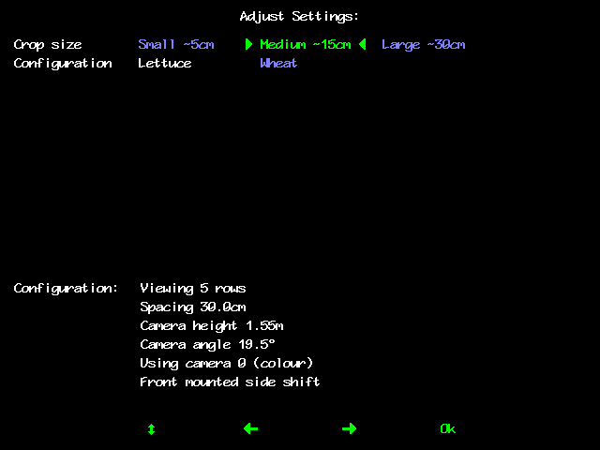

Sk1 Sk2 Sk3 Sk4 Sk5 Sk6

7.3 Advanced diagnostics menu

This screen is intended for advanced users only. It is reached from the set up screen by pressing buttons Sk1 and Sk6 simultaneously. Navigation within this screen is similar to that used in the set up screen.

The first three items on this screen display date/time of the last time operational settings were stored in flash memory (as set within the computer and not necessarily actual time), running time and area worked (based on distance x width). These cannot be changed by the user.

The remaining items on this screen are as follows:

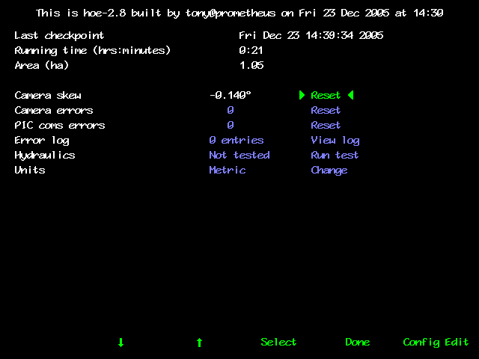

Sk1 Sk2 Sk3 Sk4 Sk5 Sk6

Camera skew
Camera skew is the angular misalignment of the camera in the horizontal plane. This angle is estimated by Robocrop’s computer programme during field operations. The rate of change of this estimated angle is highest during initial runs, after resetting to zero, or when a different configuration file is selected. It stabilizes after approximately 500m of running. During this initial learning phase it is sometimes necessary to readjust the fine offset (section 7.1).
The purpose of estimating angular misalignment and automatically compensating is to avoid the need for very accurate mechanical setting up.
As camera skew relates to a particular camera poise it is necessary to reset it to zero and allow it to estimate a new value each time the camera is moved either deliberately or by accident. Small lateral camera adjustments achieved by sliding the telescopic camera bracket should not however require a reset, as camera poise should not be significantly affected. Camera height adjustment will however require a skew angle reset due to the likelihood of small changes to camera orientation. A reset to zero is achieved by highlighting reset and pressing button SK4 labelled select.
Caution
After resetting camera skew it will probably be necessary to reset the fine offset.
Camera skews in excess of 4 degrees indicate poor camera alignment requiring improvement.

Camera errors
This is the number of camera errors automatically logged by the system during the current session. To reset it to zero highlight “reset” and press button Sk4 labelled select.

PIC com errors
This is a log of the number of errors during the current session relating to communications between the main computer and a micro-controller mounted on the implement. To reset it to zero highlight “reset” and press button Sk4 labelled select.
Error log
This is a log of a number of different automatically generated error messages (camera connections, micro-controller connections and excessive camera skew). Selecting “view log” displays single line messages that can be helpful with diagnostics. Not all messages indicate serious faults. On exit you have the option to select “clear” which erases the messages or “close” which returns to the advanced diagnostics menu without erasing. These messages are saved between sessions.
Hydraulics
This is a hydraulic test function that checks a number of components and settings relating to side shift or steering angle movement. Included in the test are micro-controller communication with the console, direction of flow, rate of flow (too fast or too slow), correct side shift potentiometer connection polarity and continuity over the stroke. It also detects mechanical obstructions preventing full travel. This is achieved by exercising the hydraulic cylinder and recording the response. It is therefore necessary to turn the hydraulic supply on.
Caution
Ensure that the side shift mechanism is clear of obstructions and people before operating the hydraulic test function.

Units
Selecting toggles between metric and imperial units. This change affects all user screens and the configuration file editor.

To exit the advanced diagnostics menu screen press Sk5 labelled “done”.
7.4 Configuration file editor
Configuration files store information relating to a specific crop planting pattern and implement/tractor geometry that is necessary for row tracking. Each combination of a different crop pattern or implement geometry requires its own configuration file.
The configuration file editor is intended for experienced users only. It is reached from the advanced diagnostics menu by pressing button Sk6 labelled “config editor”.
Less experienced users are advised to contact their Solex dealer who can supply them with customised configuration files.
This editor requires a standard PC keyboard to be connected to the PS2 socket at the base of the console. Console buttons are not used.
Overview of screen display and how to edit files
Navigation through the editor is via keyboard arrow keys with the enter key used to select a highlighted option. A context sensitive help is available by pressing the ? key with the cursor on the relevant title.
The top line lists the configuration files already stored on the machine (though this can wrap onto a second line if there are a large number of files).
The second line provides options to save and exit, create a new configuration file, toggle between metric and imperial units (also possible from advanced diagnostics menu), and select between standard and advanced versions of the editor. In the vast majority of cases the options available on the standard editor are all that is required. The advanced version offers the same features with some additional settings that would normally be factory set. Do not use the advanced editor without consulting your Solex dealer.
The settings and their values displayed on the remainder of the screen relate to the file selected on the top line, or give default values if a new file has been selected. To edit a selected file press the enter key. The cursor will jump to the first setting option which can be edited using the keyboard in the normal way. Pressing Esc will return the cursor to the headings. When you have finished creating or editing a file select Save & Exit and press enter.
Note: When you next run Robocrop you need to select the appropriate configuration file.
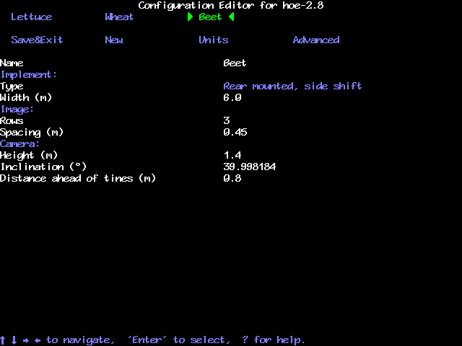
Configuration file editor screen with standard settings selected

Settings available from the standard editor
Implement settings
The first two settings relate to the implement. They are whether it uses a side shift or steered discs, and whether it is front or rear mounted. These are selected by picking the appropriate version from the list of default configuration files offered when creating a new configuration. They cannot be changed from this point in the editor (and are therefore displayed in blue).
Width is the second standard editor implement setting.
Image settings
The next settings relate to what is seen in the image. The number of rows and the spacing between rows.
It is the number of rows entered here that determines how many rows are used to construct the template. The machine will accept any number between 1 and 16. However, it is normal to enter a number that relates to the number of rows that can be seen near the bottom of the image. It is not necessary for rows to be visible all the way to the bottom of the image as parts of rows in the lower section that are out of view are automatically discarded. There is however little point in including rows that in view for less that 2/3rds of the image.
The spacing between rows is normally uniform across the field of view and is therefore a single figure. However, some crop geometries with a number of different row spacings in the same scene require a more complex arrangement. The protocol for this is based on the assumption that the pattern is symmetrical about the centre line and starts with the central row spacing working out to the edge. Figures are comma delimited. In the case of an even number of rows the first figure is always the whole row spacing, not the distance from the centre line to the next row. The following examples cover likely configurations.
Simple example
Rows 5
Spacing (in) 14
14 in
14 in
14 in
14 in
Complex example
Rows 10
Spacing (in) 14, 2, 12, 2, 2
12 in
14 in
12 in
2 in
2 in
2 in
2 in
2 in
2 in
Camera settings
The height is the vertical distance from ground level to the camera lens when the implement is at its normal working height. Inclination is the angle from the vertical. Distance ahead of the tines is the horizontal distance from a point vertically below the camera lens back to the cultivator blades.
Inclination (°)
Height
Distance ahead of tines
Additional settings available from the advanced editor
Additional Implement settings
Peak travel is side shift mechanism stroke from the mid point to one end (i.e. ½ full stroke) less a small margin to avoid hitting the mechanical end stop.
Pot scale refers to the potentiometer travel per bit. For a side shift system this would normally be the potentiometer stroke in inches divided by 4096 (for a 12bit scale). A disc steered system measures potentiometer stroke in degrees.
The pot centre is normally half the 12 bit scale i.e. 2048. Changes can be used to move the neutral position. Small changes might for example be useful in setting up a disc steered cultivator for which a zero central position is particularly important. Large changes should not normally be required and suggest poor mechanical set up.
Odometer scale relates to the distance travelled between counts from the odometer switch on one of the depth wheels (min diameter 6”, max diameter 15”). It is calculated from the number of magnets and the diameter of the ground engaging wheel according to the formula: 3.14 x Wheel diameter / number of magnets.
Additional camera settings
Camera number is normally 0 for a single camera system, but a second camera (number 1) can be fitted. This facility allows both colour and IR cameras to be fitted at once and selected by a change of configuration file according to crop colour. It would also allow two identical cameras to be fitted in different positions and orientations each with its own configuration file.
Distance behind the tractor rear axle is the horizontal distance from the rear axle to the camera. For front mounted systems the editor asks for the distance the camera is ahead of the rear axle.
Focal length refers to the focal length of the camera lens.
Distortion is a figure relating to lens distortion that is used in correcting for its effects.
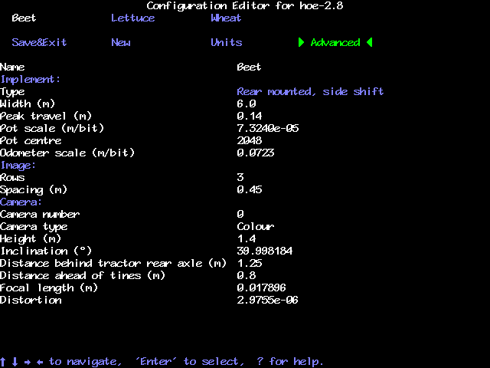
Configuration file editor screen with advanced settings selected
Maintenance and Storage

Please follow the maintenance and storage instructions below in order to ensure your Robocrop precision guided hitch stays in first class working order

- There are no lubrication points on the side shift.

- Check that dirt does not build up on the side shift rails and rollers and clean if necessary. However, take care not to pressure wash electrical components such as the potentiometer, camera, solenoid valves, or micro-controller box.

- Regularly check the routing of hoses and cables and protect against chaffing.

- Always store the hitch undercover. Although the camera, loom and junction box are shower proof damage may result if they are exposed to wet weather for extended periods.

- The console and camera should always be stored in a dry atmosphere.

- Always ensure the correct 20 amp fuse is fitted in the power supply.

- Always ensure the correct supply polarity is adhered to.
Blue = negative, Brown/Orange/Black + (fused side) = positive.

- Always ensure the correct oil flow direction is followed Red=supply, Blue=return.

Trouble shooting
Problems have been divided into three categories listed below. Please consult your Solex dealer for any other problems.
- Console fails to start up correctly
- Console shows a working screen but the side shift does not respond
- All systems appear to be functioning but crop tracking performance is poor
1. Console fails to start up correctly

Is there a live video image?
Check that the image responds to movement in front of the camera.
Check camera connections.
If problem persists consult dealer

Does the working screen appear?
Does any text appear on the screen?
Make a note of any messages at the bottom of the screen and consult your dealer
Check that the console has a 12v supply
Check fuse in loom near battery connection
Check connection to battery
Check voltage at power supply plug on console, minimum 12volts
If problem persists consult dealer

Yes
No
Yes
No

2. Console shows a working screen but the side shift does not respond
Is the video image live? Check that the image responds to movement in front of the camera
Switch to manual side shift control (Sk 2, working screen) and exercise the side shift.

Shut down the console and restart. If the problem persists consult your dealer
Does the side shift mechanism centre when the hitch is raised?
Follow fault finding procedure for poor crop tracking performance
Is the hitch lift icon displayed and do the crosses overlaid on the video screen disappear when the hitch is lifted?
Yes
No
Manual side shift OK
Manual side shift not OK
Check that the hitch raise sensor is operating correctly. The sensor detects a magnet on the trailing arm. It may be out of adjustment or damaged

Run the hydraulic test function from the advanced diagnostics menu. If problems persist consult your dealer
Yes
No
No
Does Robocrops speed indicator show a similar value to the tractors and does the stopped brake icon disappear when moving?
Check the speed sensor on the trailing arm. It detects a ring of magnets. Ensure it is not damaged and correctly connected

Yes
No
Yes
Check hydraulic supply is on and correctly connected
3. All systems appear to be functioning but crop tracking performance is poor
With the hitch in work do the green lines representing the template appear symmetrically in the image and aligned with crop rows? (Use the “Align” function from the working screen)
Appropriate configuration file selected?
Select an appropriate file from the set up menu. If an appropriate file is not available either create one using the configuration editor or consult your dealer
The camera may not be correctly adjusted or an inappropriate crop height selected, refer to Section 5 of the manual
With the implement in work do crosses appear down the centre of the image and does the lift icon go away?
Symptoms of poor vision tracking? i.e.
Yellow or red crosses moving erratically
Persistent tracking warning triangle
Low image quality < 1/3
The lift sensor may be damaged or incorrectly fitted
Does the side shift pull off to full stroke almost immediately on moving forward?
Both potentiometer and hydraulics may be connected the wrong way round. Run hydraulic test.
Check the speed sensor (fitted to a depth wheel) and its connections
Does the image freeze and image quality bar dip intermittently?
Does Robocrop’s speed indicator register a value similar to that of the tractor and the stopped icon go away?
Does the side shift appear to oscillate rapidly or act very slowly?
The hydraulic flow rate may be set too high/low, run hydraulic test from the advanced diagnostics menu
Ensure that the lower links are adjusted to eliminate lateral movement. If problems persist consult your dealer
Is the lens dirty?
Clean lens
Has the camera been changed or disturbed?
Reset camera skew angle from the advanced diagnostics menu
Does tracking appear to be pulled off by a tractor wheel in the image?
If possible move camera and edit configuration file to follow rows that leave > ¼ row between crop and wheel
Is the configuration allowing the maximum number of rows to be tracked?
Robocrop performance improves as more rows are tracked. Edit the configuration files to maximise row numbers.
Is the crop predominately green?
Red crops require a special camera Consult your dealer
Very small crops or severe weed infestation can under some conditions be difficult to track. If problems persist consult your dealer
The lift sensor may be poorly adjusted and operating when depth wheel follows ground contours
No
Yes
Yes
No
Yes
Yes
Yes
Yes
Yes
Yes
Yes
Yes
Yes
No
No
Yes
No
No
No
No
Yes
No
No
No
No
Do the green template lines appear skewed?
Reset camera skew from advanced diagnostics menu
No
Yes

Solex Corp
220 S. Jefferson,
Dixon, CA 95620
Tel. (707) 678 - 5533. Fax. (707) 678 - 9788
Email – sales@solexcorp.com

