USE AND MAINTENANCE MANUAL

1.1. Manufacturer: FALC S.r.l.
via Proventa n.41 - Faenza (Ravenna) - ITALIA -
Tel. ++39 0546 29050
Fax ++39 0546 663986
e-mail: info@falc.eu
www.falc.eu

1.2. Series: AGILA – UNIKA
WIND – VISION

1.3. Model:

1.4. Series number:

CAREFULLY NOTE:
• THIS MANUAL MUST ACCOMPANY EACH EXAMPLE OF THE ABOVE MENTIONED SERIES.
• IN ORDER TO ENSURE A COMPLETE UNDERSTANDING OF THE MACHINE’S CORRECT FUNCTIONING THE USER MUST FULLY READ EACH SECTION OF THE MANUAL.
• PARTICULARLY IMPORTANT NOTES REGARDING SAFETY ARE WRITTEN IN BOLD PRINT.
• ANY USERS WHO MUST CARRY OUT PARTICULAR OPERATIONS ON THE MACHINE FOR WHICH NO SPECIFIC INSTRUCTIONS HAVE BEEN SUPPLIED MUST DIRECTLY ASK OUR SALES OR TECHNICAL OFFICE.

INDEX
1. General indications
2. Use conditions
3. Operator conditions
4.1. Connection of the shredder to tractor
4.2. Shredder use
4.3. Rear cover
4.4. Front use
4.5. Detaching the shredder from the tractor
4.6. Transport
4.7. Work height adjustment
4.8. Maintenance and repairs
5. Guarantee
6. Norms to follow for correctly ordering spare parts
- Safety pictograms


2. CONDITIONS OF USE

FALC shredders are built to be coupled to an ideal tractor provided with a 3-point hitch and a Cardan shaft transmission.
The shredders are used to shred the remains after maize, wheat, soya bean, cotton, sunflower, artichokes, tobacco harvests, etc., to allow a better formation of the humus necessary for the soil fertility, for the elimination of parasites and to achieve the optimal condition that restores the land for further cultivation. They are also used to shred grasses and pruning remains in fruit orchards and vineyards.

ANY OTHER USE OF THE SHREDDERS IS TO BE CONSIDERED ILLEGAL AND PROHIBITED BY THE MANUFACTURER.

Model | Weight * | Hp  Tractor | Kw  Tractor | Model | Weight *
Agila 1600 | 660 | 50 - 100 | 37 - 74 | Unika 1600 | 656
Agila 1800 | 706 | 50 - 100 | 37 - 74 | Unika 1800 | 688
Agila 2100 | 750 | 50 - 100 | 37 - 74 | Unika 2100 | 751
Agila 2300 | 910 | 50 - 120 | 37 - 90 | Unika 2300 | 887
Agila 2500 | 965 | 50 - 120 | 37 - 90 | Unika 2500 | 926
Agila 2700 | 1020 | 50 - 120 | 37 - 90 | Unika 2700 | 968
Wind 2700 | 1326 | 70 - 140 | 52 - 103 | Vision 2700 | 1196
Wind 3200 | 1441 | 70 - 140 | 52 - 103 | Vision 3200 | 1316
Wind 3200 DT | 1681 | 70 - 140 | 52 - 103 | /
Wind 3600 | 1566 | 70 - 140 | 52 - 103 | Vision 3600 | 1440
Wind 4000 | 1671 | 70 - 140 | 52 - 103 | Vision 4000 | 1545
*The weight includes 2 rear wheels.
To achieve the lifting capacity and tractor stability it is necessary to respect the following conditions:
M x s ≤ 0,2 T x i + Z (d + i) M ≤ 0,3 T

i = tractor wheels wheelbase | T = Tractor mass
d = distance of front axis from ballast | Z = ballast mass
s = protrusion of shredder rear axis | M = shredder mass

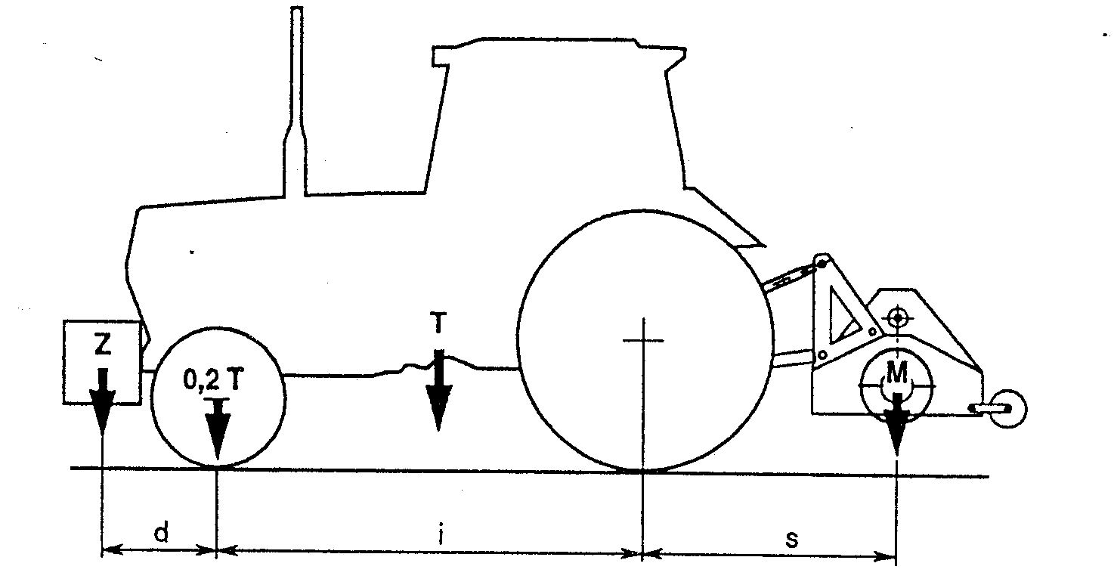

IT IS ABSOLUTELY FORBIDDEN TO ALLOW PERSONS, ANIMALS OR THINGS TO CLIMB OR BE TRANSPORTED ON THE AGILA, UNIKA, WIND, VISION
SERIES SHREDDERS

3. CONDITIONS FOR THE OPERATOR

- During the use of the shredder, the operator must remain on the tractor in the driver's position.
The operator cannot leave the driver's position on the tractor if he has not disengaged the power take-off from the tractor itself and has not waited until the moving parts of the shredder (rotor, etc.) are completely stationary. The stop time of the moving parts of the shredder is roughly 3 minutes.
- Under normal conditions, that is, with the rear lid closed, the operator must ensure that when starting up the shredder and during its operation, there are no persons within a radius of 20 m around the machine. The operator must immediately stop both the tractor as well as the shredder if one or more persons enter within a 20 m radius around the machine.
- The operator must not activate the hydraulic lift of the tractor without having first disengaged the tractor's power take-off. Before lifting the shredding machine from the ground using the tractor's hydraulic lift, the operator must ensure that the power take-off is disengaged.
- It is strictly prohibited to go in reverse while continuing to chop; i.e. with the tractor PTO engaged. Before starting the reverse manoeuvre, always wait till the rotor has completely stopped.
- The front part of the machine is equipped with oscillating protective devices designed to prevent any material from being thrown out while working. You need to check these devices constantly to make sure that they are free to oscillate and that they are not deformed (crooked or bent). This check is very important particularly on stony ground where these protective devices are subject to numerous impacts during normal work. If the protective devices are deformed, they must be replaced immediately.
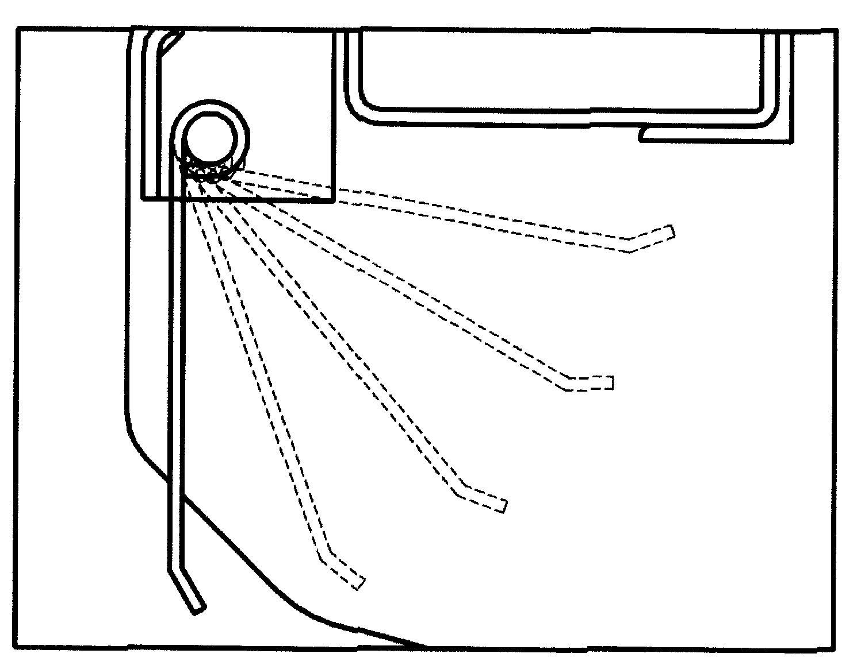

- To protect your eyes from any objects thrown out from the shredder while working, always wear suitable work goggles.


4.1. CONNECTION OF THE SHREDDER TO THE TRACTOR

- All Falc shredders can be mounted onto any type of tractor provided it is supplied with a 3-point universal hitch
- The shredder must be positioned on level ground, in a good stable position.
- The tractor must approach the shredder in reverse until its arms are in correspondence with those of the shredders 3 point. Any operator on the ground must maintain a distance of at least 5 m from the machine.
- Position the lower 3 point pin and block with the split pins provided.
- Connect the upper arm of the tractor to the upper dowel of the 3 point, adjusting so that the machine assumes a horizontal position with respect to the ground.
- Position the cardan shaft and ensure that its ends are well connected to the power take-off of the tractor and the multiplier. Fix the anti-rotation chains (catenelle) on the cardan to both the tractor and shredder side. The tractor engine must be off during this phase so that the power take-off is not activated by any wrong manouveure.
- After the completion of this operation the tractor’s hydraulic lift may be activated just enough to free the support legs (if present) which must then be completely raised and blocked with the pins provided.
- For standard machines
Tractor PTO = 540 revolutions/minute for Agila – Unika
Tractor PTO = 1000 revolutions/minute for Wind – Vision

4.2. USING THE SHREDDER

After having correctly connected the shredder to the tractor, the operator can start to work, always
respecting the conditions mentioned in point 3 (point 4.3 if working with the lid open).
The tractor’s advancement speed is independent of the shredder; it is up to the operator to judge and determine the best machine output depending on some factors, namely the tractor’s power, height of the remains to be shredded, adjustment of the working height, etc..
When the machine starts, it is necessary that the rotor is free to turn until the reaching of the standard rotation speed. So the machine has to be out from the material to shred.
When starting the machine, the worker who drives the tractor should increase the power and therefore the speed of the PTO gradually to allow the rotor, now at rest, to gradually increase it’s speed.

Some tractors are equipped with an automatic system – SOFT START – that assists the operator at the start of the shredder and permits a gradual increase in the speed of the PTO(from 0 to 540 or 1000 rpm).
It is recommended that it is verified whether or not the tractor in use is equipped with this type of system, and if so, the system should be used at all times when using a shredder.
If the tractor is NOT equipped with a Soft Start system, the GRADUAL increase in the speed of the PTO(from 0 to 540 or 1000rpm) must be accomplished directly by the operator, using caution with the power of the tractor. In fact, the engagement of the PTO at to high of an RPM, or increasing the speed of the PTO of the tractor to rapidly, and as a consequence, the top pulleys of the shredder can cause slippage of the belts in the side drives, and as a result the rapid wear of the drive belts.
The belts, in fact mus drive the rotor which has a very high mass or inertia, and as a consequence, requires a few seconds (this time depends on the weight of the rotor) to reach working speed.
TO AVOID THE RAPID WEAR OF THE DRIVE BELTS, CAREFUL ATTENTION MUST BE PAID WHEN ENGAGING THE PTO OF THE TRACTOR. THE INCREASE IN SPEED OF THE PTO FROM 0 TO 540 OR 1000 MUST BE GRADUAL.
CONFIRM WHETHER OR NOT THE TRACTOR IS EQUIPPED WITH THE SOFT START SYSTEM FOR THE PTO, AND IF SO, ALWAYS USE THIS SYSTEM WHEN USING A SHREDDER.

Gear box: temperatures until 90° - 100° are normal at work.
Temperatures over 130°: at these temperatures the oil inside the box loses its technical features.

4.3. REAR COVER FOR ROTOR MAINTENANCE – Agila – Wind

Open or remove the rear cover for servicing the rotor only when the machine is DISCONNECTED from the tractor's power take-off (PTO) and only for the time necessary for performing maintenance.
During work the cover must be closed and bolted to the frame.

4.4. FRONT USE – Unika – Vision

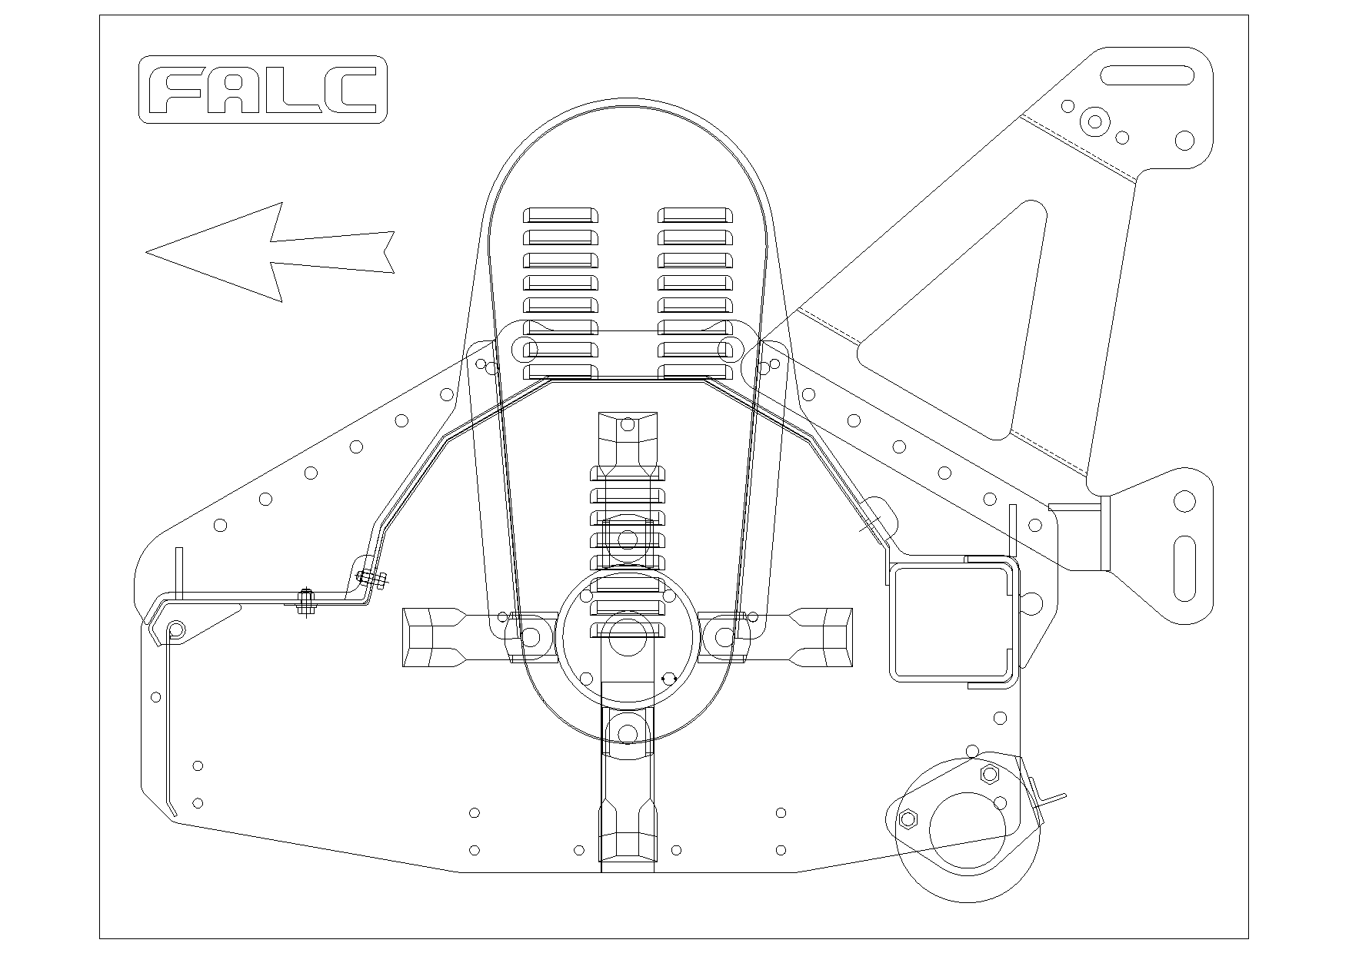

Shredders model Unika and Vision have facilities to be mounted on the front of the tractor or also to be mounted on reversible tractors.
The gearboxes (overdrives) of such shredder are standard equipped with a through Power Take-Off.I
Rotation of the gearbox (overdrive) becomes necessary if , when working with the shredder in front of the tractor, the rotation direction of the Power Take-Off is inverted with respect to the usual.
To decide whether it is necessary to carry out the rotation of the gearbox (overdrive), it is recommended to always verify the rotation direction of the Power Take-Off

For any doubts, it is recommended either to get in touch to the area distributor or directly to the manufacturer offices.

4.5. DISCONNECTION OF THE SHREDDER FROM THE TRACTOR

The following are necessary precautions for a correct disconnection of the shredders from the tractor:
- Stop the tractor on level ground, activate the handbrake, turn the engine off and disconnect the power take-off.
- Place the shredder on the ground ensuring that its position is both stable and horizontal
- Stop the tractor motor and wait for about 3 minutes until all the moving parts of the shredder stop.
- Disconnect the cardan joint from the tractor’s power take-off and place it in the appropriate shredder support.
- Disconnect the shredder from the 3-point hitch of the tractor first by sliding out the split pins that block the dowels and then by removing the pins themselves.
- Climb onto the tractor again and move it forward to completely free the tractor’s arms from the 3rd point of the shredder.

4.6. TRANSPORT

During operation, the shredders rest on the wheels at the rear, on the roller as well as on the lateral slits. In the front they are kept lifted by the tractor’s hydraulic hitches’ arms .
During transport the shredders are completely supported by the tractor (see point 2).
Due to the handling which is necessary during the loading, unloading and storage ensure that only the appropriate equipment which can support the weight of the machine itself is used and use the pegs which are purposely positioned on the machine.

4.7. ADJUSTING THE WORKING HEIGHT

Before using the shredder it is necessary to take particular care in adjusting the working height.

- The working height adjustment is carried out by moving the connection flanges of the roller by one or more holes.
- The working height adjustment is carried out by moving the wheels flanges by one or more holes.
- The working height adjustment is carried out by moving the lateral skids by one or more holes The working height adjustment is correct when the cutters or the hammers skim the ground without actually touching it. If the rotating movements touch the ground due to an incorrect adjustment, the result will be a greater power consumption by the tractor and a faster wear rate of the same rotating movements.
- The machine must always be in a horizontal position with respect to the ground.

Rullo Agila - Unika | Rullo Wind - Vision
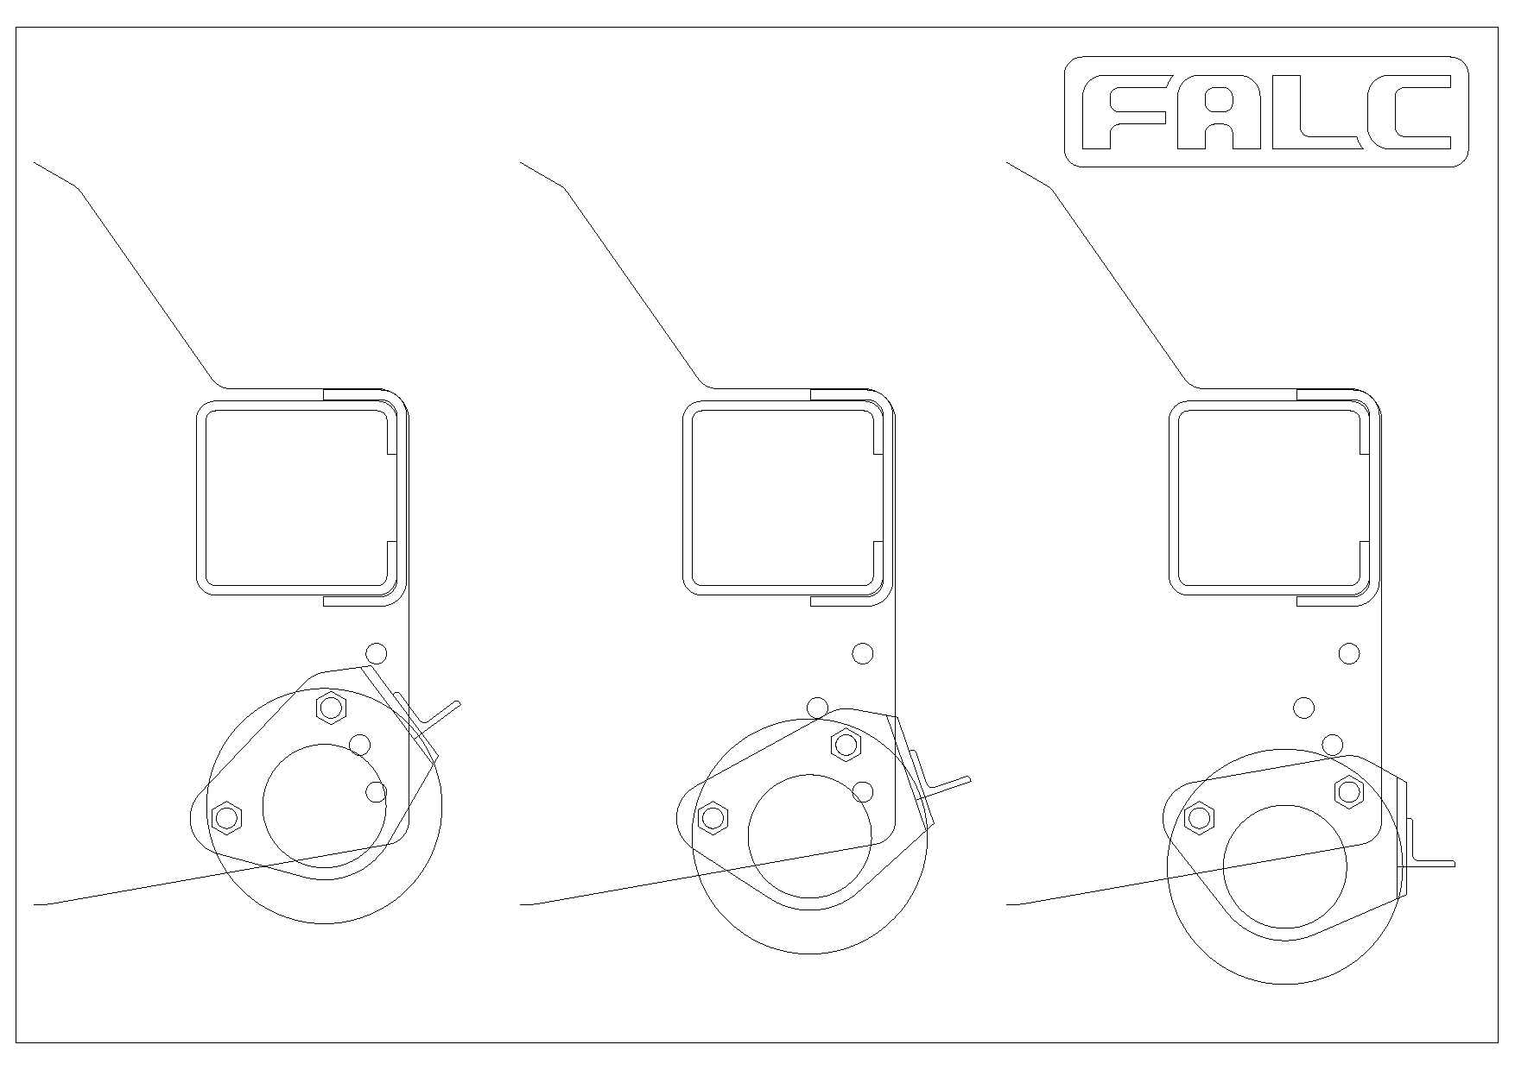 | 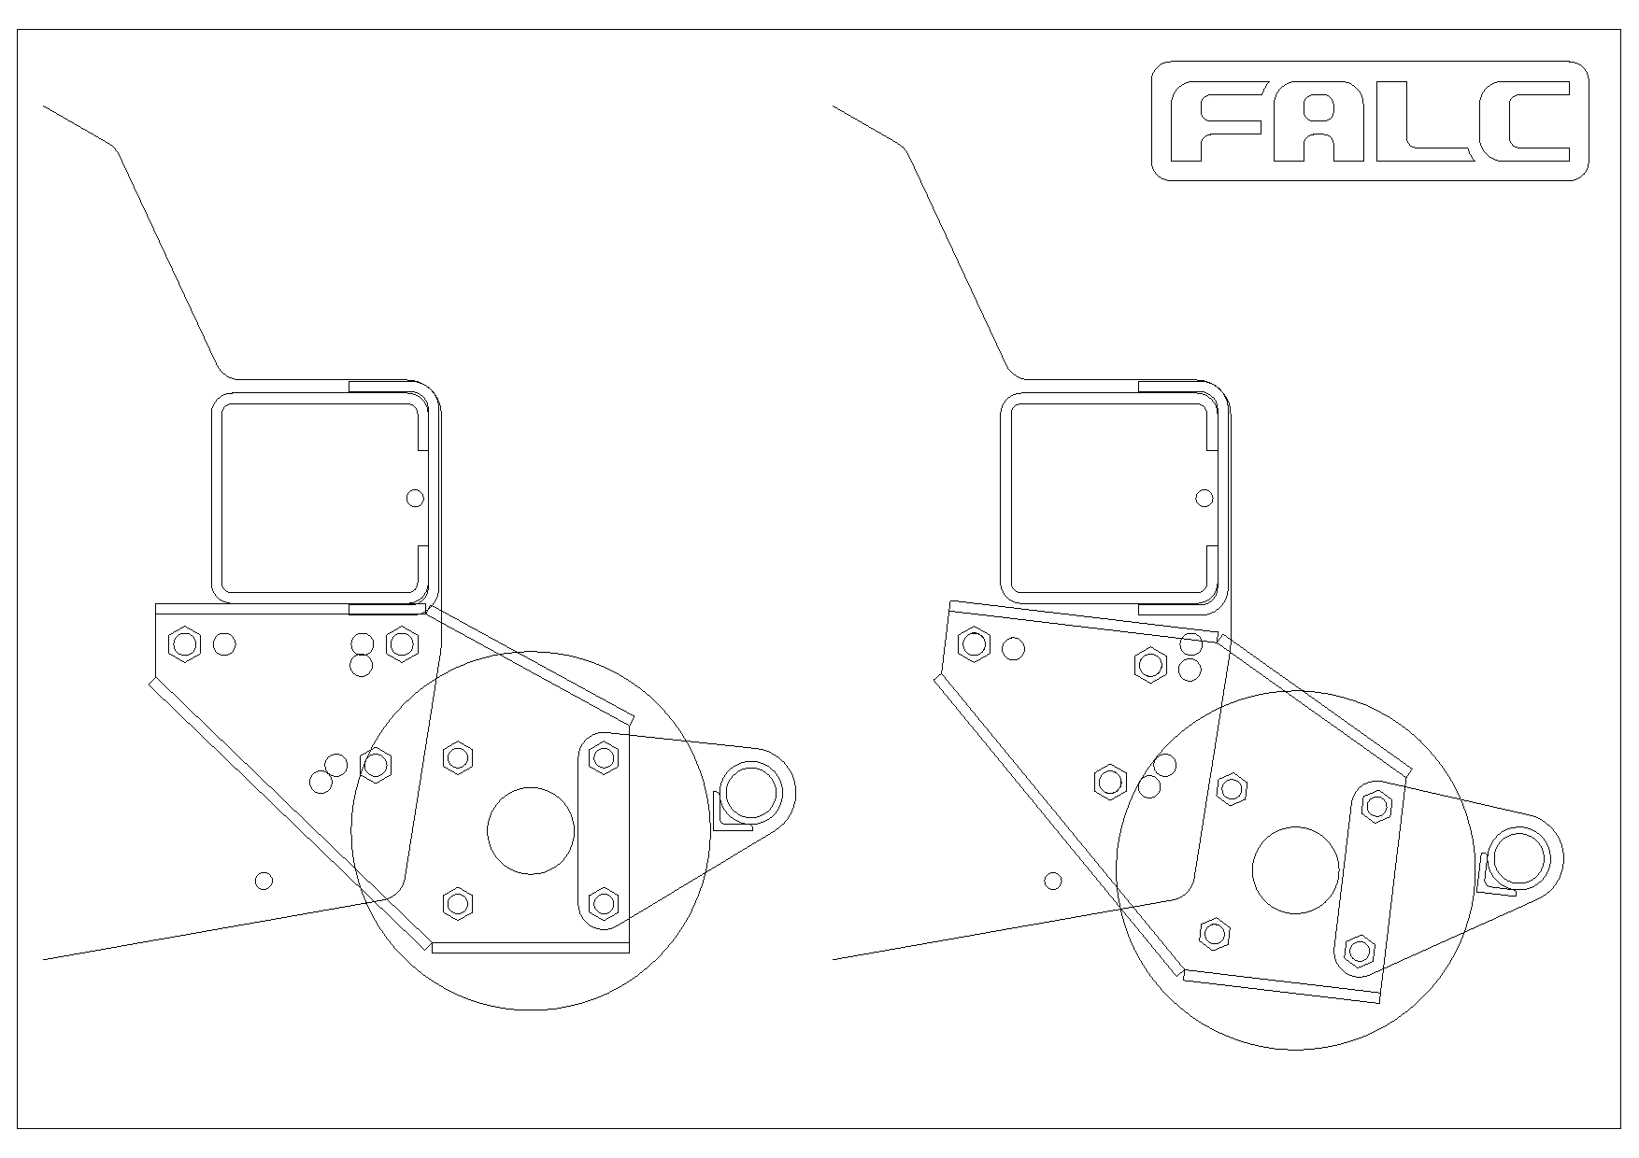
Slitta Agila – Unika – Wind - Vision | Ruote Agila – Unika – Wind - Vision
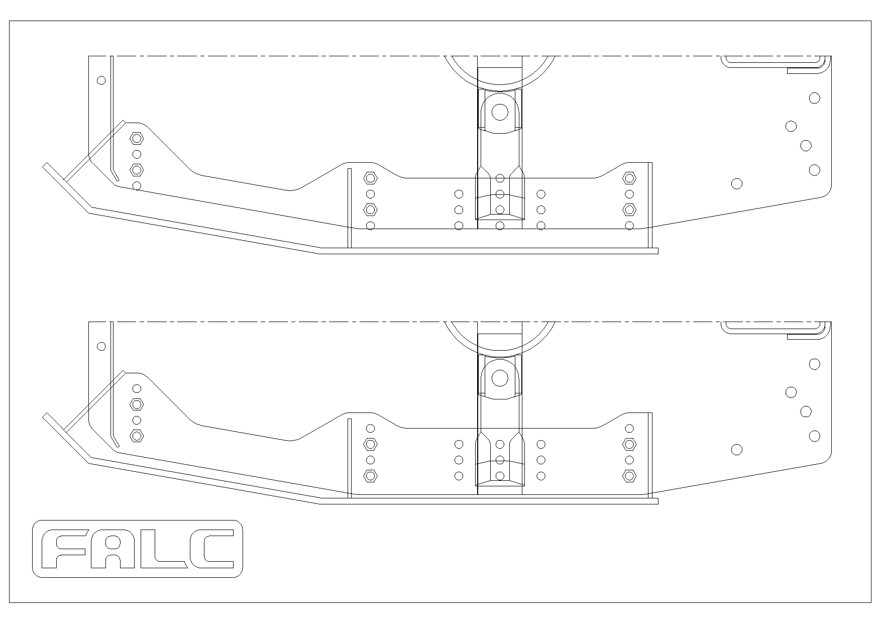 | 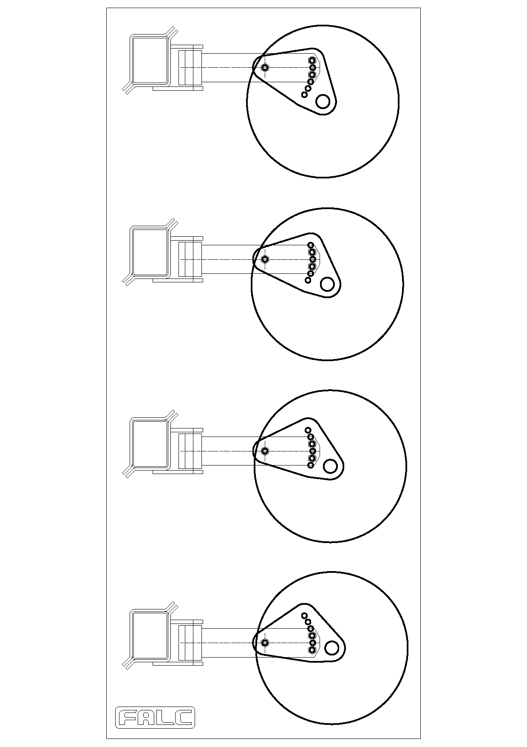

4.8. MAINTENANCE AND REPAIRS

Before approaching the machine to carry out any maintenance or repairs, it is compulsory to take some precautions:
- Stop the tractor on level ground
- Place the shredder on the ground
- Activate the handbrake
- Disengage the p.t.o
- Turn the engine off
- Wait for about 3 minutes until all moving parts of the shredder have stopped.
In case of specific maintenance or repair work where it is necessary that the machine is lifted from the ground or turned around, it is indispensable to use the suitable equipment built for such purposes. It is always recommended that the area sales assistance or ideally equipped mechanical workshops are consulted. The machine weight is in point 2 of this manual.
For intervention on parts of the machine which may reach elevated temperatures such as the multiplier, the bearings, the belts etc., wait until they have cooled. The cooling time for these parts may vary depending on the work carried out before stoppage as well as external atmospheric conditions.

4.8.1. Maintenance

Even though all the shredders are delivered well greased and lubricated, hereafter is a list of rules which must strictly be adhered to, so as to obtain better results.

- After the first hour of operation
- Check that all bolts and screws are correctly tightened.
- Daily
- Check the oil level in the transmission box.
- Lubricate the Cardan joint (see the specific Instruction manual relative to the Cardan joint)
WARNING : the Cardan joint is in general supplied by FALC and is suitable for the effective power required for the tractor-shredder link-up. In case of replacement always use a Cardan joint with characteristics not inferior to those of the original Cardan shaft.
- Every 8 hours of work
Grease the rotor supports using the appropriate grease nipples indicated on the machine. Grease in moderation applying a little grease at a time
Grease all of the points indicated on the machine.
- Every 8 working hours
- Check the belts’ tension so as to prevent premature wear of the belts themselves and the pulleys. The correct tension of the belts is achieved when, by pushing on the central point between the pulleys, the belt yields a maximum of 10 mm.
- Every 300 working hours
- Change the oil in the transmission box.
- Check that the breather plug of the multiplier is free of dust and earth internally. If in doubt replace the breather plug.
On delivery the transmission box is lubricated with:
DIN 51517 part 3 CLP - ISO VG 460 (which corresponds to the previous SAE 140)
(Mobil code: Mobilgear 600 XP 460)
WARNING: Do not disperse the used oil but use the appropriate means provided for its disposal.

- If vibrations should be noted during work IMMEDIATELY STOP THE SHREDDER AND DISCONNECT THE P.T.O. Check for breakage or excessive wear of the cutters or of the hammers. If necessary immediately provide for a partial or total replacement of these, taking the utmost care to maintain the balance of the rotor, that is, by replacing the broken cutters (hammers) and those diametrically opposite the broken ones.
- Further check if there is residue or encrustation on the knives, hammers or on the rotor. If this is so clean immediately.
- Prior to a period of inactivity, it is recommended that the machine is accurately cleaned machine of remains accumulated during operation. During the period of inactivity, it is recommended that the machine is protected from atmospheric agents.
- FOR SHREDDER “STONE LINE” VERSION, ONLY: every 8 hours check the locking of the nut of the hammer-pin.

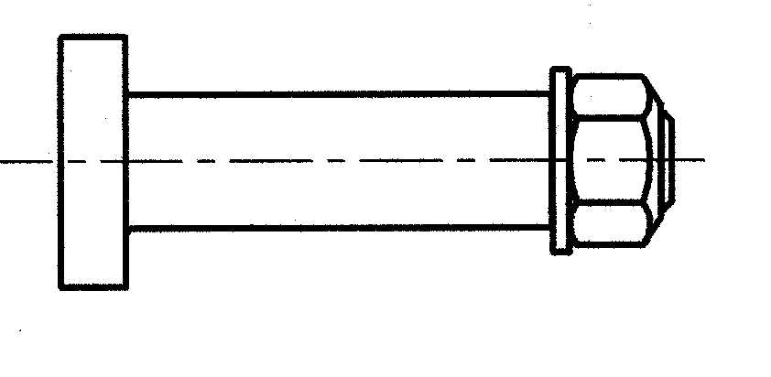

4.8.2. Possible causes of inconveniences and relative interventions.

If the shredder vibrates in an evident manner
CAUSE :  Breakage of one or more cutters (hammers) which causes the rotor to lose its balance.  The bearings of the rotor’s supports are worn.  Remains and encrustations are visible on the cutters (hammers) and/or the rotor. | INTERVENTION :  Replacement of the broken cutters (hammers) and of those diametrically opposite the broken ones.  Replacement of the supports.  Cleaning of the cutters (hammers), cleaning of the rotor

If the rotor rotates at a speed lower than specified
CAUSE : | INTERVENTION :
The belts have become loose.  Excessive wear of the belts and pulleys. | Reset the correct tension of the belts.  Replace any worn parts.

An excessive wear of the cutters (hammers) is noted.
CAUSE : | INTERVENTION :
The cutters (hammers) touch the ground during operation. | Reset the machine’s correct height from the ground.

4.8.3. Replacement of the belts

Agila – Unika shredder

Carry out the following operations to replace the belts:
- Remove the belts’ safety guard
- Unscrew the locking bolts of the gearbox (overdrive) and jackshaft
- Reduce belts tension unscrewing the bolts that you find on the gearbox (overdrive) and on the top of the jackshaft.
- Slide the belts from their respective pulley’s races and replace them with new ones. Carefully check that the new belts are the same as the old ones, both as regards the length as well as the type. FALC s.r.l, installs toothed belts type SPB on standard series machines.
- To place the belts in tension again, reset the adjustment bolts previously loosened. The bolts must be adjusted in such a way that the upper pulley remains parallel and on the same plane as the lower pulley. If the upper pulley is in an incorrect position with respect to the lower one, the belts do not transmit the right power and will hence have a shorter life.
- Check the tension of the belts
- Tighten the fixing bolts previously loosened
- Remount the belts’ safety guard.

Wind - Vision shredder

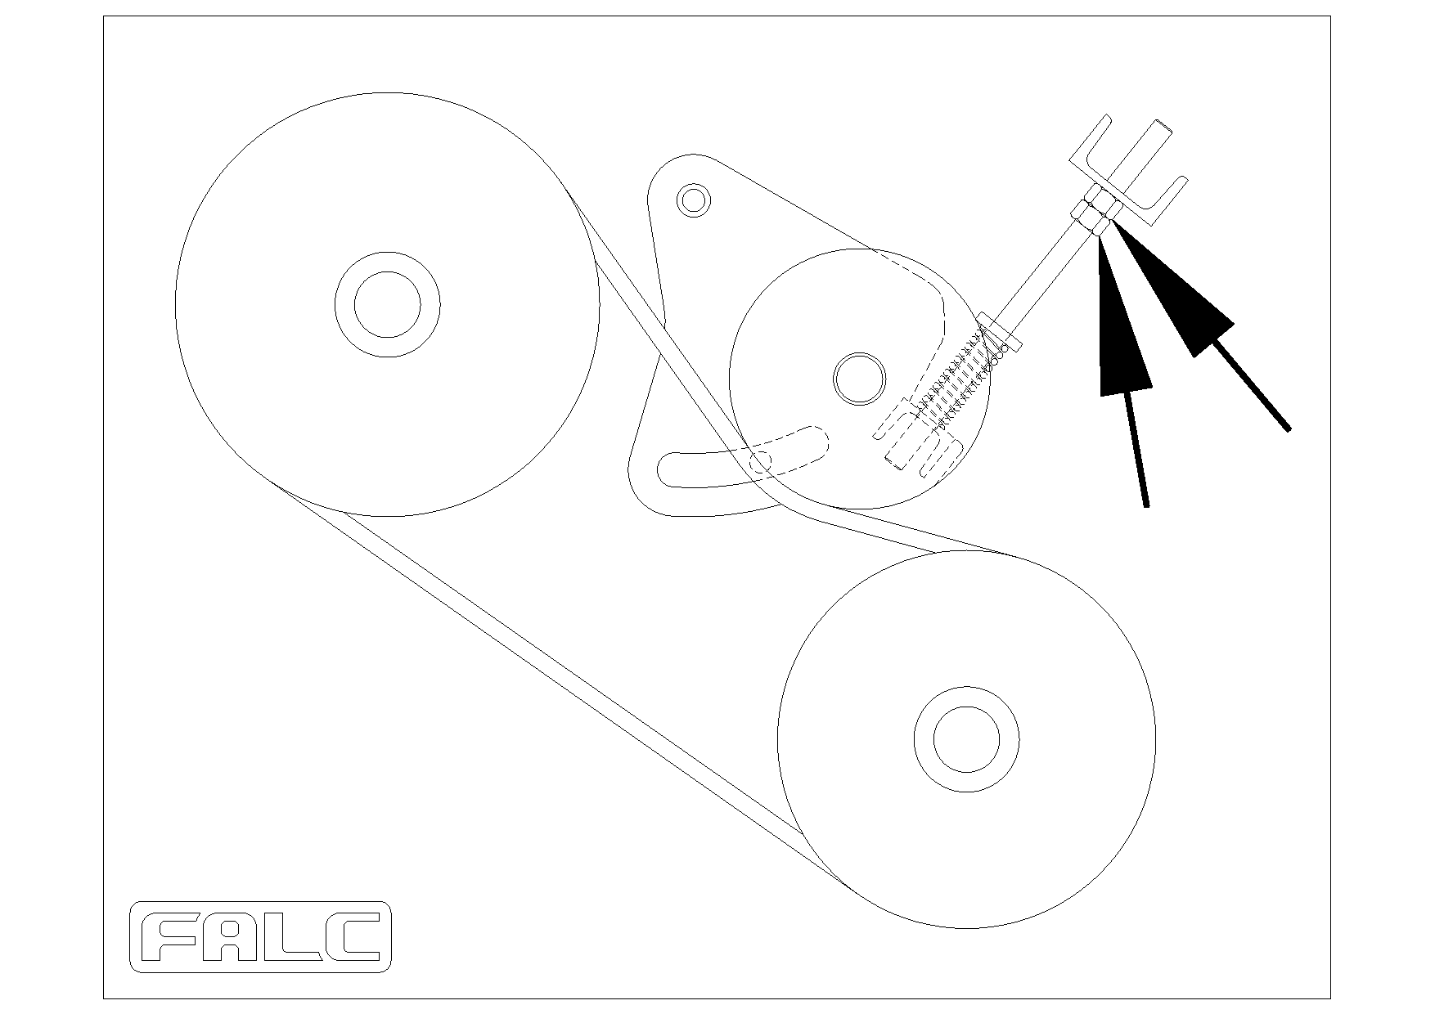

Carry out the following operations to replace the belts:
- Open the belts’safety guard.
- Loosen the 4 nuts of the rivetted bar.
- In this manner, a movement of the idle pulley is obtained and consequently the tension of the belts is reduced.
- Slide the belts from their respective pulley’s races and replace them with new ones. Carefully check that the new belts are the same as the old ones, both as regards the length as well as the type. FALC s.r.l, installs toothed belts type SPB on standard series machines.
- To place the belts in tension again, turn the nuts of the rivetted bar previously loosened.
- Check the tension of the belts
- Tighten the fixing bolts previously loosened
- Close the belts’safety guard.

4.8.4. Assembling and dismantling the pulleys

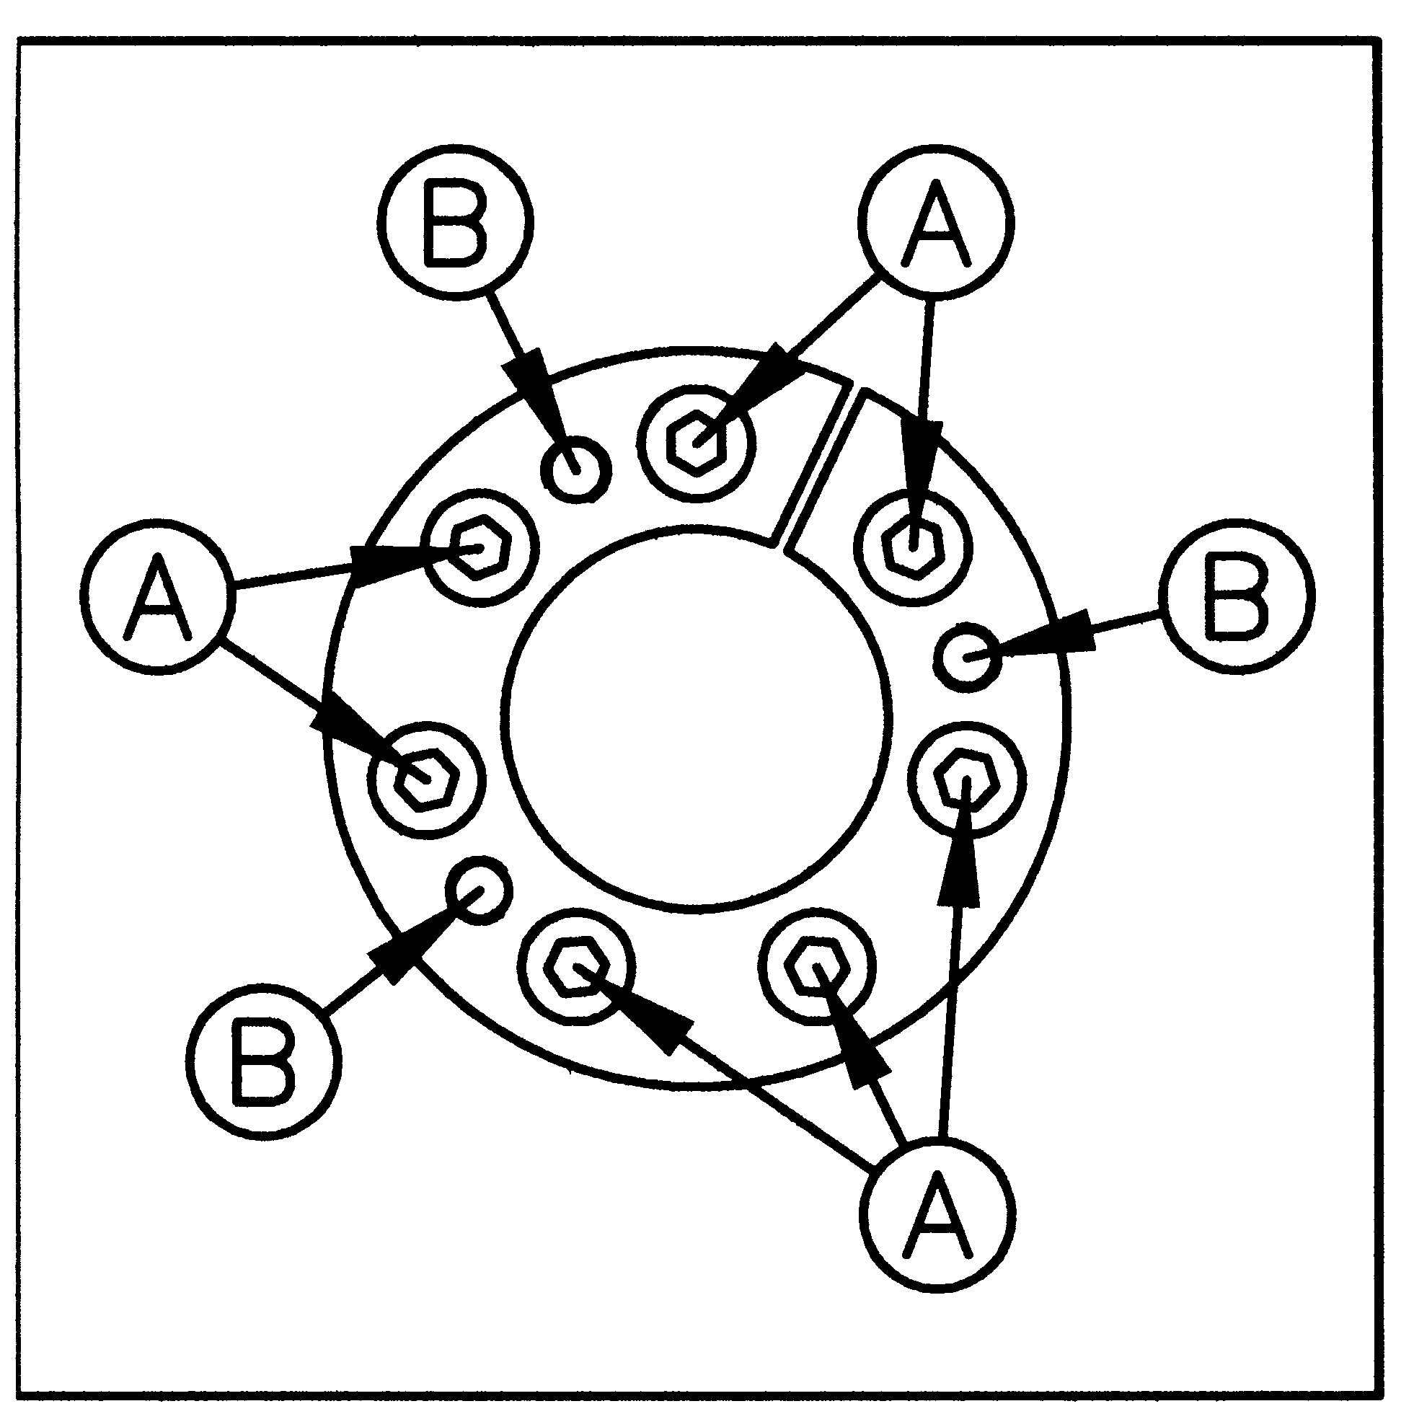

The pulleys are fixed on the relative shafts by means of a coupling similar to that shown in the diagram above.
- To dismantle the pulleys adhere to the following steps::
Loosen the bolts (A) with the relative key
Remove “x” no. of bolts (A) and insert them into the threaded holes (B) tightening in a uniform manner
After a few turns of the bolts the pulley can easily be slipped out from the shaft
- To assemble the pulleys adhere to the following steps:
Insert the coupling in the pulley’s hole
Connect it all to the shaft ensuring that the pulley is in the right position
Tighten in a uniform manner the bolts (A) with the relative key
ATTENTION : Tightening moment = 40 N/m (4,1 kg/m)

5. GUARANTEE

- The guarantee is valid 1 year from the date of the delivery. The company is committed to replacing parts which present material or manufacturing defects in as short a time as possible. The manpower necessary for replacing parts is excluded from the guarantee. Any transport or forwarding expenses are excluded from the guarantee.
- The guarantee ceases if breakage is the result of forza maggiore, incorrect use of the machine or any erroneous action carried out by the purchaser, employees or third parties. Repairs, replacements, modifications carried out by the purchaser or for the purchaser without the authorisation of the manufacturer are included in these actions. Incorrect use of the machine is understood to mean actions which are not listed in the user norms listed in this instruction manual.
- Parts which due to their very nature or use are subject to inevitable deterioration or wear are excluded from this guarantee.
- The bearings and oil retainers are not under guarantee.
- The cardan shaft is not under guarantee.
- The following standards are valid for the parts for which a warranty is requested:
- the piece to be replaced must be returned to the manufacturer the moment in which a request is made for a new piece.
- the spare parts are always invoiced when forwarded.
- only examination by the manufacturer’s technicians can result in the guarantee being upheld and, therefore, accredited.

6. NORMS TO BE FOLLOWED FOR CORRECTLY ORDERING SPARE PARTS

In order to quickly deal with the orders relative to spare parts it is necessary to specify :
- Type of machine, Model, Series number.
(Eg. Wind 3200 series' number. XXXXX)
- Number of the spare parts table in which the piece in question is to be located, identification number, piece code.
(E.g. Table no. YY ; Item no. JJ ; Code KKKKKK)
- Exact denomination of the item.
- Quantity of pieces requested.
- Instructions for the forwarding.
(rail, postal package, courier, etc.)
- The minimum delivery time for the parts requested is 3 days from the date of receiving the order.

If any part of this instruction manual should result insufficiently clear, we ask you to kindly contact your closest authorised dealer or contact us directly at our technical and commercial departments.

This handbook or any part of it cannot be reproduced, copied or published without prior written authorization of FALC.
FALC reserves the right to modify the here described specifications at any time without committing itself to update this handbook every time.

